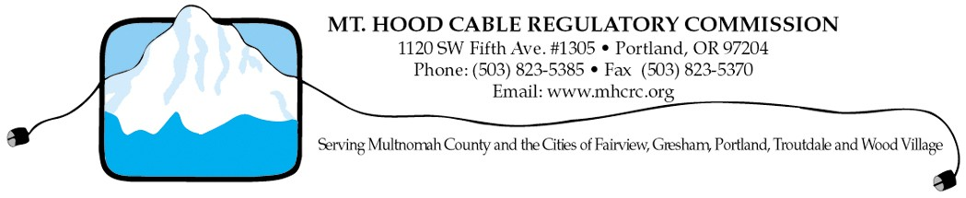Mt. Hood Cable Regulatory Commission
POSITION DESCRIPTION

Mission Statement
The Mt. Hood Cable Regulatory Commission advocates for and protects the public interest in the regulation and development of cable communications systems in Multnomah County and the Cities of Fairview, Gresham, Portland, Troutdale and Wood Village; monitors and helps resolve cable subscribers' concerns in these jurisdictions; and participates in the planning and implementation of community use of communications technologies which make use of the public right of way.

Summary of MHCRC Activities
- Provides consumer protection for citizens and subscribers in cable television matters, including complaint resolution
- Determines grant recipients for the Community Access Capital Grant, a competitive grant program which allocates about $1.4 million annually to libraries, schools, local governments and non-profit community organizations
- Directs the Institutional Network (I-Net) and the related $1 million annually to ensure reliable and affordable fiber connectivity and network resources are available to local public institutions such as schools, libraries and public safety sites
- Enforces cable company compliance with franchise agreements
- Conducts franchise negotiations, renewals and transfers of ownership
- Oversees and monitors two community media organizations
- Promotes community and institutional uses of cable-based technologies
- Participates in advocacy efforts for legislative activities and FCC proceedings

Primary Responsibilities of Commissioners
- Oversee financial matters of the Commission, including development of an annual budget for recommendation to the member jurisdictions;
- Attend Commission meetings (about 8 per year) and participate on committees;
- Provide regular reports and liaison to elected officials of appointing jurisdiction;
- Keep informed and educated about issues related to Commission activities.

Time Commitment
The full Commission generally meets the third Monday of the month at 6:30 pm, about eight times per year. The meeting location generally alternates between Portland and Gresham. Committees choose their meeting times and dates as necessary. Members are expected to take the necessary time to study pre-meeting materials and to participate in briefings for the elected officials in their jurisdiction.

Other MHCRC Facts
- Is comprised of eight volunteer community members appointed by the city councils and the county commission.
- Regulates cable services franchise agreements with Comcast, Qwest, Cascade Access and Verizon.
- Serves about 152,000 cable subscribers.
- Assisted in the resolution of nearly 250 cable subscriber complaints in 2008.
- Supports two community media organizations: Portland Community Media and MetroEast Community Media.
- Has an annual operating budget of nearly $448,000 and 3.3 full-time staff.

Further Information
Contact 503.823.5385 or visit the MHCRC website at www.mhcrc.org

