Help Save the Arbor Lodge Community Wireless Network!

Join us!

September 15, 3-5:00pm
Arbor Lodge Park

The Personal Telco Project is a volunteer-powered 501(c)3 non-profit in Portland that builds Community Wireless Networks, providing a wifi connection to the Internet, free to the end user.

For 2½ years, such a network has existed near Arbor Lodge Park. Dozens of people connect to this network every week, receiving free access to a shared resource.

The Internet Service Provider that has sponsored this network is withdrawing support soon. We need a community of users to contribute to the costs of maintaining the connection in order for the network to survive. Please join us to learn how you can help and to let us know whether you value this service!

For more information, contact us by email:
info@personaltelco.net
Help Save the Arbor Lodge Community Wireless Network!

Join us!

September 15, 3-5:00pm
Arbor Lodge Park

The Personal Telco Project is a volunteer-powered 501(c)3 non-profit in Portland that builds Community Wireless Networks, providing a wifi connection to the Internet, free to the end user.

For 2½ years, such a network has existed near Arbor Lodge Park. Dozens of people connect to this network every week, receiving free access to a shared resource.

The Internet Service Provider that has sponsored this network is withdrawing support soon. We need a community of users to contribute to the costs of maintaining the connection in order for the network to survive. Please join us to learn how you can help and to let us know whether you value this service!

For more information, contact us by email:
info@personaltelco.net
Help Save the Arbor Lodge Community Wireless Network!

Join us!

September 15, 3-5:00pm
Arbor Lodge Park

The Personal Telco Project is a volunteer-powered 501(c)3 non-profit in Portland that builds Community Wireless Networks, providing a wifi connection to the Internet, free to the end user.

For 2½ years, such a network has existed near Arbor Lodge Park. Dozens of people connect to this network every week, receiving free access to a shared resource.

The Internet Service Provider that has sponsored this network is withdrawing support soon. We need a community of users to contribute to the costs of maintaining the connection in order for the network to survive. Please join us to learn how you can help and to let us know whether you value this service!

For more information, contact us by email:
info@personaltelco.net
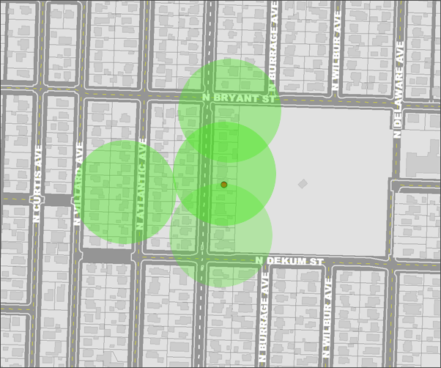
Approximate coverage map

We have more equipment and can expand the network's footprint as people are willing to host devices on their homes, while still sharing the same internet connection.

The community meeting is intended to allow interested people to discuss the advantages of free wifi in the community and how to communally pay for it. We welcome your input and will do our best to answer any questions.

Sunday, September 15
3:00 – 5:00 p.m.

Look for the red canopy!
See you there!
For more info: https://personaltelco.net/
Approximate coverage map

We have more equipment and can expand the network's footprint as people are willing to host devices on their homes, while still sharing the same internet connection.

The community meeting is intended to allow interested people to discuss the advantages of free wifi in the community and how to communally pay for it. We welcome your input and will do our best to answer any questions.

Sunday, September 15
3:00 – 5:00 p.m.

Look for the red canopy!
See you there!
For more info: https://personaltelco.net/
Approximate coverage map

We have more equipment and can expand the network's footprint as people are willing to host devices on their homes, while still sharing the same internet connection.

The community meeting is intended to allow interested people to discuss the advantages of free wifi in the community and how to communally pay for it. We welcome your input and will do our best to answer any questions.

Sunday, September 15
3:00 – 5:00 p.m.

Look for the red canopy!
See you there!
For more info: https://personaltelco.net/

